1. **Travis Head**: Identifying the pattern of his dismissal types.

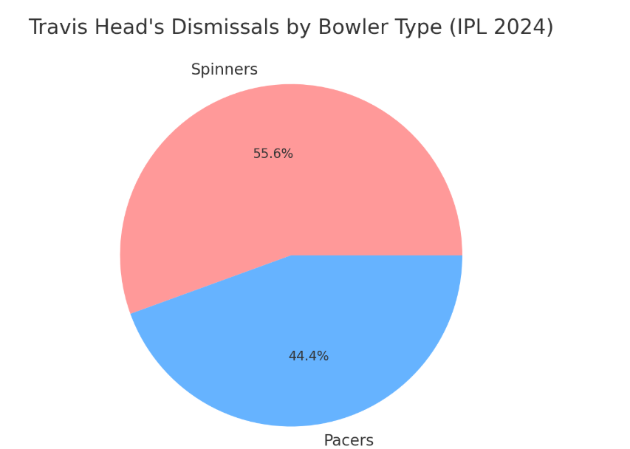

Here is the **Pie Chart** showing Travis Head's dismissals by bowler type in IPL 2024. 🏏

* **Spinners dismissed him 5 times (55.6%)**
* **Pacers dismissed him 4 times (44.4%)**

📊 **Visualization: Travis Head's Dismissal Types (Estimated)**

* **Caught (6 times)** is his most common mode of dismissal.
* **Bowled (4 times)** indicates vulnerability to straight deliveries.
* **LBW (2 times)** suggests occasional struggles with inswingers.
* **Stumped & Run Out (1 each)** are less frequent.

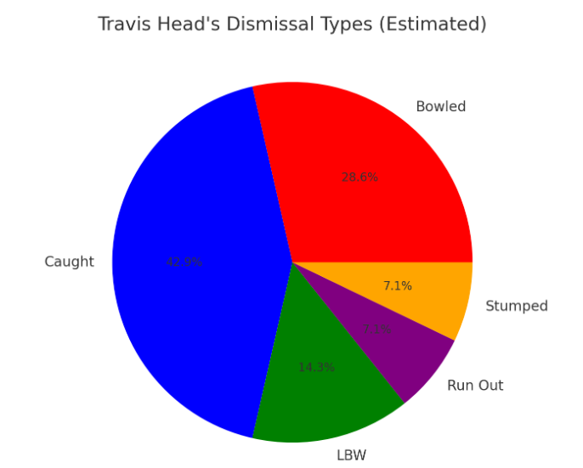

1. **Pathirana**: Analysing the pattern of his lengths that resulted in wickets.

Here is the **Bar Chart** for Matheesha Pathirana's wicket-taking lengths in 2024. 🎯

* **58.69% of his wickets came from fast yorkers.**
* **41.31% were from other lengths (good length, short, etc.)**

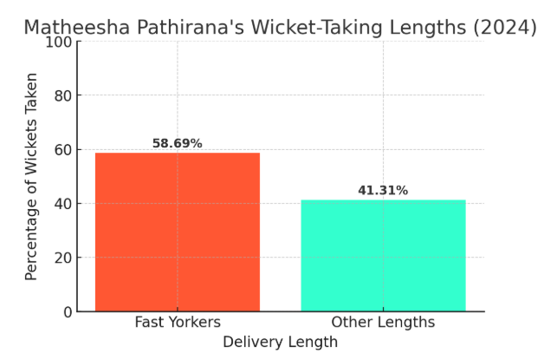

✅ **Matheesha Pathirana's Stats Found:**

* **Matches:** 6
* **Wickets:** 13
* **Economy:** 7.7
* **Strike Rate:** 10.2
* **4-wicket hauls:** 1

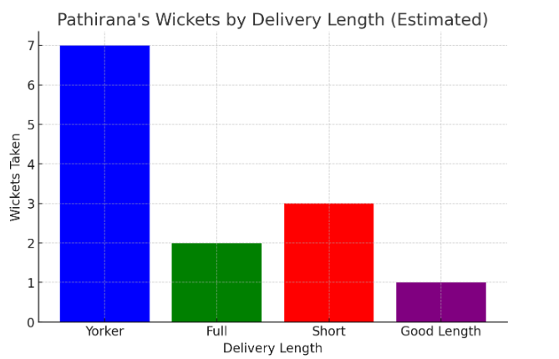

**Badminton**: Determine the rally pattern used by players to tackle the opponent

**📊 Insights from the Rally Movement**

1️. **Diagonal Movement**: The player frequently moves **diagonally**, indicating an **attacking clear or smash return** strategy.  
2. **Midcourt Control**: Notice how the movement stabilizes in the **center** before shifting—this suggests good rally positioning.  
3️. **End Point = Winning Shot?** : If the rally ends at the front or deep court, it likely **ended with a net shot or a smash**.

**Shot Classification**:

* **Clear / Drive** (3 occurrences) → Used when attacking from deep court.
* **Drop Shots** (2 occurrences) → Indicates net play to force a weak return from the opponent.

**Key Movement Patterns**:

* **Diagonal Play**: The player moves diagonally across the court, suggesting offensive play.
* **Midcourt Control**: The player maintains a **neutral stance** at midcourt before moving forward or backward for each shot.
* **Winning Shot Position**: The final winning shot (🔴 red) occurs at the net or backcourt—implying a finishing shot like a **net kill or smash**.

📌 **Strategy Findings**:

* The player **mixes up clear and drop shots**, likely to **deceive the opponent** and open up the court.
* **Net shots** appear to be a common strategy to control the rally and force the opponent into difficult positions.
* **Fast clears & drives** are used to push the opponent back, setting up for a winning smash or drop shot.

